Anytime ChildCare

Transport Policy
If a child attending Anytime ChildCare requires to be transported from School to our venue, our Transport Policy will be enabled. At Anytime ChildCare we take the transporting of children extremely seriously. We ensure that all children have the relevant consent, we ensure that the driver is competent and hold a full UK driving licence (Add in how you do this). We are aware of the hours that the driver has driven, we know the routes used and traffic conditions and have a contingency plan in place for breakdown/emergency. We take into account the weather, journey time and distance and the needs of the children who are being collected. Where possible, staff will alternate Drop offs/pick ups to limit the time children spend with one member of staff.
Every journey, all children and adults must be wearing a seatbelt and in the appropriate booster/car seat for their age, height and weight. This will be discussed with parents. The car will contain a fire extinguisher and a first aid kit, and the member of staff will be trained in first aid and will also carry a club mobile for emergencies. There will be no eating or drinking during car journeys due to staff not being able to watch and be responsive to children in the event of needing first aid.
Children’s responsibility:
- Follow instructions
- Not to eat or drink in the vehicle
- Not distract the driver, ie kick the seats
- Must wear a seatbelt/restraint and all times Drivers responsibility:
- Vehicle is clean and tidy
- Children have all of their belongings, including medication and these are safely stored in the boot
- All children are secured safely in the car, with seatbelts, boosters etc. A check by the driver/member of staff will be done
- Aware of their point of contact- The Manager/Deputy
- No personal data is left in the car, ie registers
- There is enough fuel in the car. The children must NOT be taken to the petrol station and must not be left in the car unattended. The driver must ensure that they have filled up with fuel without the children present
- Not to drive under the influence of drugs, alcohol or medication. See staff ‘smoking, alcohol and drugs’ policy. It is illegal to smoke in a vehicle being used for business purposes when passengers are carried
- Follow the designated route unless there is a diversion
- Are required to produce proof of insurance cover, vehicle licence, an MOT and service history before using the vehicle. Copies will be retained and these will be checked annually
- A first aid kit and fire extinguisher should be carried in the vehicle
- There is no lone working, so more than 1 child is present or more than 1 adult
- All doors of the vehicle must have childproof locks enabled
- Under no circumstances must children be allowed to gain access to vehicle keys. When not in use, vehicle keys must be kept in a safe place. Children may not use the main controls of vehicles, steer cars or use petrol pumps.
- No child to sit in the front of the vehicle- all children must sit in the rear of the vehicle and must be supervised by a minimum of one member of staff
- Report any safeguarding concerns using the usual procedure

Breakdown/Emergency/Crashes:
We will do are utmost to protect the children and will ensure the drier is first aid trained.
In the event of the above, notify the emergency services immediately. Then if safe to do so notify the Manager.
If needed park the vehicle in a safe place and ensure children get out of the vehicle safely.
We have a contingency plan in place for breakdown and emergency – state what this is.
What constitutes as an emergency and explain what happens. Link to Risk assessment.
Any accidents, incidents will be reported to the Manager, reported and parents/carers notified.

The driver sends the manager a text message before they leave. If the driver and the children do not return within enter time then a second vehicle will go along the designated route and look for the group. A phone call will be made but the Manager understands that the driver may not be able to answer. Where possible, the drove will have hands free.
The group might be delayed due to traffic, late from school, an accident. All will be recorded.

Insurance: All staff who use their cars to transport children to and from the setting, have the appropriate business insurance on their vehicle. It is the driver's responsibility to ensure that their insurance covers them to drive their own vehicle for business use. Any additional cost is the responsibility of the driver/ Out of School Club.
State what you do for security/ ad in risk assessment and make relevant to car/ minibus.
Seatbelts/ Car seats and boosters: Children who are to be carried in the vehicle must be fitted with appropriate seat belts, personal restraints and/or booster seats for the size and ages of the children, complying with latest legislation at all times. Children must normally use a child car seat until they’re 12 years old or 135 centimetres tall, whichever comes first. All children must travel in rear seats (any seats behind the driver) if a child car seat or an adult seat belt isn’t fitted.
Children aged 3 or older must:
- use a child car seat if there’s one available in a minibus
- use an adult seat belt if child car seats are not fitted or are unsuitable
Children with disabilities or medical conditions: The same rules apply for children with disabilities or medical conditions, but they can use a disabled person’s seat belt or a child restraint designed for their needs. A doctor can issue an exemption certificate if a child is unable to use a restraint or seat belt because of their condition.
Height-based seats: Height-based seats are known as ‘i-Size’ seats. They must be rearfacing until your child is over 15 months old. Your child can use a forward-facing child car seat when they’re over 15 months old. You must check the seat to make sure it’s suitable for the height of your child.
Weight-based seats: The seat your child can use (and the way they must be restrained in it) depends on their weight. Only EU-approved weight-based child car seats can be used in the UK. These have a label showing a capital ‘E’ in a circle and ‘ECE R44’.
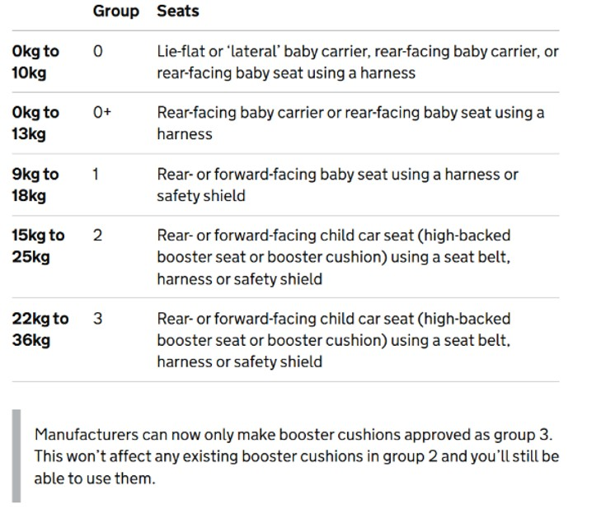
Minibuses:
- Advice from the DVLA or other suitable source to verify our specific circumstances will be sought.
- Staff who drive the minibus hold a D1 category on their license to drive a 16+ seater minibus. If staff passed their test after 1997 they won’t have it on their license automatically and must take the appropriate training. Staff can still drive a 9 to 16 seater if they are over 21 and had their license for 2 years.
- Where the person doing the driving is paid and expected to do it as part of their role they would need a PSV license and the employer would need an operators (PCV O) license. This is what is known as a right to be carried and this is a grey area, as it may potentially be covered by section 19 (not for profit) transport rules.
- Add in other relevant information

Further info and guidance:
https://www.rospa.com/policy/road-safety/advice/vehicles/car-seats https://capt.org.uk/car-safety/ https://www.gov.uk/child-car-seats-the-rules

This policy should be read in line with the Arrivals policy and all relevant risk assessments.
This policy was adopted by: [Insert club name] | Date:
To be reviewed: [Insert date] | Signed: [by  Manager/Proprietor]
Written in accordance with the Statutory Framework for the Early Years Foundation Stage (2025). Safety of Outings [3.90].

